Local Media and Social Media Engagement
2025 AMO Conference

To all Heads of Council:

The 2025 Association of Municipalities of Ontario (AMO) Conference runs from Sunday, August 17 to Wednesday, August 20 in Ottawa. The Conference is an opportunity for Ontario’s municipal leaders to come together at a time when Ontario communities face continued economic uncertainty and challenges that outstrip municipal resources and responsibilities.

AMO’s Local Media and Social Media Toolkit helps you amplify media coverage of municipal priorities while profiling your participation at the conference, including meetings with ministers and more.

Reporters from across Ontario will cover the event and they will be looking for the local angle to a broader story. It offers you an opportunity to highlight the important work that municipalities are doing together through AMO to find solutions to shared challenges.

Template for Local Media Advisory
We are attaching a template media advisory that will help you prepare notices for local media. Again, it’s the local angle that reporters are trying to capture. Your municipality may want to make plans to be available for media interviews throughout the conference.
If your municipality is scheduled to meet with a Minister, the subject of that meeting may be of interest to your local media.

Reporters can attend the conference in Ottawa. The template advisory provides details on media registration.

Social Media Templates
We have attached templates for Facebook, X, LinkedIn, and Instagram. The conference generates significant social media interest and traffic. AMO will be posting during the conference on X @AMOPolicy, LinkedIn, Instagram, and Facebook. The conference hashtag is #AMO2025.

We encourage you to create your own content. Participating in social media discussions is an opportunity to highlight your municipality’s priorities at the conference.

Conference Highlights
Keynote presenters include Ontario Premier Doug Ford and his Government’s ministers, Marit Stiles, Leader of the Ontario NDP and Official Opposition, Bonnie Crombie, Leader of the Ontario Liberal Party, Mike Schreiner, Leader of the Green Party of Ontario, and Robin Jones, AMO President. Keynote speaker journalist Andrew Coyne will discuss the remarkable changes in the provincial, national and international political landscape in since he addressed the AMO Conference last year.

With more than 60 sessions, workshops and networking receptions to engage with colleagues and leaders from across the province, there is sure to be something of interest to your local media. Key session topics include housing and homelessness, infrastructure, Indigenous relations, trade and tariffs, artificial intelligence, and more.

Please take a moment to review the AMO Conference program and identify the sessions that may be of interest to your community and local media. Familiarizing yourself with the program will make it easy for you to explain how your attendance at the conference will benefit your community.

With thousands of delegates expected once again, local media relations are best handled directly. To facilitate interviews, please provide local media with a means to contact you during the conference, either directly or through your municipal office. All media are required to register onsite in Room 201 at the Rogers Centre Ottawa. Attending media are encouraged to book accommodation as soon as possible, if needed.

If you have any questions or need any help with the media advisory or the social media templates, do not hesitate to contact Megan Abraham at Redbrick Communications, at abraham@redbrick.ca

Sincerely,

Petra Wolfbeiss, Director
AMO Membership Centre

2025 AMO Conference Template Media Advisory

[NAME OF Municipality] participating in the 2025 AMO Conference

[NAME OF COMMUNITY], [DATE], – [NAME OF MAYOR / REEVE / CHAIR] will join more than 2,500 participants at the Association of Municipalities of Ontario's 2025 AMO Conference in Ottawa from August 17 to 20.

The 2025 AMO Conference brings municipal and provincial officials together as Ontario’s communities continue to face economic uncertainty fueled by the trade and tariff dispute with the United States.

The Ontario Government and municipalities must work together to protect and strengthen our social and economic prosperity. Municipal services and infrastructure underpin Ontario’s competitiveness and must be on strong financial footing.

This year’s event features more than 60 speakers, sessions and workshops, reflecting the broad scope of municipal responsibilities. The Premier, members of cabinet and opposition leaders will all speak, as well as AMO President, Robin Jones.

Key session topics will include affordable housing and growth, homelessness, infrastructure, property reassessment, artificial intelligence, and more. Experts will share insights on the impacts of the trade war and tariffs on municipalities and future opportunities. AMO will also launch its first Indigenous Reconciliation Action Plan.

[NAME OF MAYOR / REEVE / CHAIR] is particularly interested in sessions related to…

The annual conference is an opportunity for municipal officials to work together on solutions to today’s big challenges, to learn, and to create new opportunities that benefit our communities.

In addition to the conference program, municipal staff and officials will take part in hundreds of municipal delegation meetings with provincial ministries. [NAME OF MAYOR / REEVE / CHAIR will be meeting with – INSERT INFORMATION IF YOU WOULD LIKE TO HIGHLIGHT YOUR DELEGATION MEETING].

All media are required to register onsite in Room 201 at the Rogers Centre Ottawa. Attending media are encouraged to book accommodation as soon as possible, if needed. Reporters can access key conference information on AMO’s website, www.amo.on.ca.

Media Contacts:
[MUNICIPAL CONTACT, POSITION, TELEPHONE NUMBER, EMAIL]
Brian Lambie, AMO Media Contact, 416-729-5425, lambie@redbrick.ca
Follow the conference on social media: X, LinkedIn, Instagram, and Facebook. Hashtag: #AMO2025

Conference Social Media Templates

The following templates are designed to help you communicate your participation in the 2025 AMO Conference. The AMO Conference hashtag is #AMO2025.

NOTE: Please use the higher quality graphics available for download.

POST 1  [Name of Reeve / Mayor / Chair] of [Name of Community / Social Handle] will be joining municipal leaders from across Ontario at the 2025 AMO Conference in Ottawa, August 17-20. #AMO2025 | 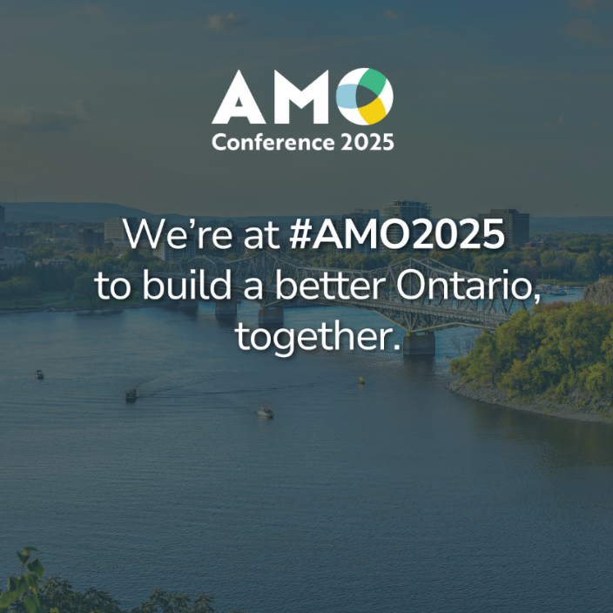
POST 2  [Municipality name] is taking part in the #AMO2025 annual conference, where Ontario’s municipal leaders are coming together to connect on solutions and urge provincial support to secure our shared economic and social prosperity. https://www.amo.on.ca/2025-amo-conference | 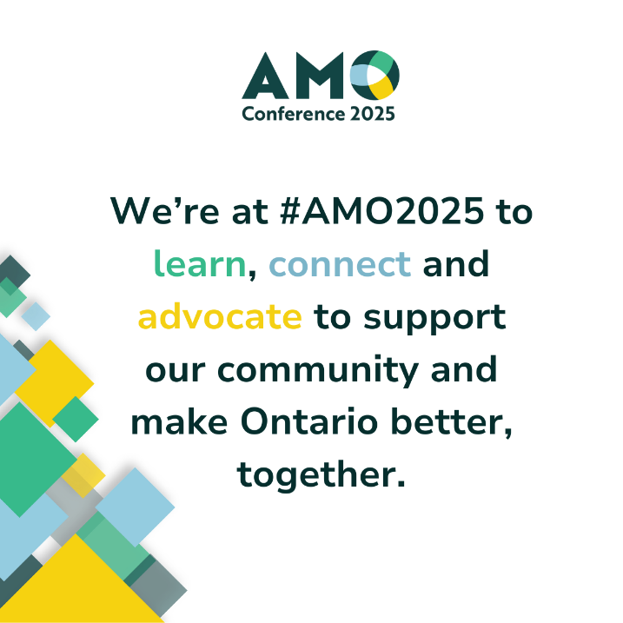
POST 3  [Municipality name] is participating in the 2025 AMO Conference, where Ontario’s municipal leaders are gathering for more than 60 sessions on key priorities, such as housing and homelessness, infrastructure, growth, Indigenous relations, AI, trade and tariffs. #AMO2025 https://www.amo.on.ca/2025-amo-conference | 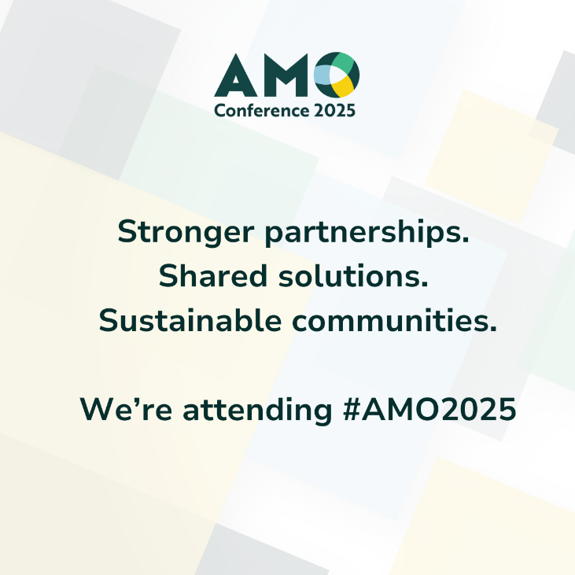
POST 4  [Municipality name] is taking part in #AMO2025 alongside thousands of municipal leaders. It’s an opportunity to advocate for our community, and share our perspective directly with the provincial government.  https://www.amo.on.ca/2025-amo-conference | 